CPE301 – SPRING 2019

Design Assignment 5

Student Name: Rimon Sawa

Partner: Biruk Gebremeskel

Student #: 5001529281

Student Email: sawar1@unlv.nevada.edu

Primary Github address: <https://github.com/sawar1/UNLV301>

Directory: DA5

Design Assignment 5:

1. Interface the provided NRF24L01+ RF Module to the ATmega328p using the SPI interface. Using the earlier developed code for ADC, transmit the ADC value of the internal temperature sensor, or LM35 sensor between two RF Modules. The ATmega328p interfacing the RF Modules should alternate between TX and RX modes every 0.5 secs (hopefully they are not both at TX and RX modes in the same interval). The temperature of both ATmega328p’s should be displayed on both ATmega328p’s.

1. **INITIAL/MODIFIED/DEVELOPED CODE**

#ifndef *F_CPU*

#define *F_CPU* 16000000UL

#endif

#include <avr/io.h>

#include <util/delay.h>

#include <avr/interrupt.h>

#include <stdbool.h>

#include <stdio.h>

#include <string.h>

// Set up UART for printf();

#ifndef BAUD

#define BAUD 9600

#endif

#include "inc/STDIO_UART.h"

// Include nRF24L01+ library

#include "inc/nrf24l01.h"

#include "inc/nrf24l01-mnemonics.h"

#include "inc/spi.h"

void print_config(void);

void read_adc(void); // Function Declarations

void adc_init(void);

volatile unsigned int adc_temp;

char outs[20];

// Used in IRQ ISR

volatile bool message_received = false;

volatile bool status = false;

int main(void)

{

// Set cliche message to send (message cannot exceed 32 characters)

char tx_message[32]; // Define string array

*strcpy*(tx_message,"hello i am cody"); // Copy string into array

// Initialize UART

uart_init();

adc_init();

// Initialize nRF24L01+ and print configuration info

nrf24_init();

print_config();

// Start listening to incoming messages

nrf24_start_listening();

while (1)

{

read_adc();

adc_temp = (adc_temp*500)/1023 + 20;

*snprintf*(outs,sizeof(outs),"%3d\r\n", adc_temp); // print it

*strcpy*(tx_message,outs); // Copy string into array

nrf24_send_message(tx_message);

*_delay_ms*(1500);

if (message_received)

{

// Message received, print it

message_received = false;

*printf*("Received message: %s\n",nrf24_read_message());

// Send message as response

*_delay_ms*(500);

status = nrf24_send_message(tx_message);

if (status == true) *printf*("Message sent successfully\n");

}

}

}

// Interrupt on IRQ pin

ISR(INT0_vect)

{

message_received = true;

}

void print_config(void)

{

*uint8_t* data;

*printf*("Startup successful\n\n nRF24L01+ configured as:\n");

*printf*("-------------------------------------------\n");

nrf24_read(CONFIG,&data,1);

*printf*("CONFIG 0x%02X\n",data);

nrf24_read(EN_AA,&data,1);

*printf*("EN_AA 0x%02X\n",data);

nrf24_read(EN_RXADDR,&data,1);

*printf*("EN_RXADDR 0x%02X\n",data);

nrf24_read(SETUP_RETR,&data,1);

*printf*("SETUP_RETR 0x%02X\n",data);

nrf24_read(RF_CH,&data,1);

*printf*("RF_CH 0x%02X\n",data);

nrf24_read(RF_SETUP,&data,1);

*printf*("RF_SETUP 0x%02X\n",data);

nrf24_read(STATUS,&data,1);

*printf*("STATUS 0x%02X\n",data);

nrf24_read(FEATURE,&data,1);

*printf*("FEATURE 0x%02X\n",data);

*printf*("-------------------------------------------\n\n");

}

/* INIT ADC */

void adc_init(void)

{

/** Setup and enable ADC **/

ADMUX = (0<<REFS1)| // Reference Selection Bits

(1<<REFS0)| // AVcc - external cap at AREF

(0<<ADLAR)| // ADC Left Adjust Result

(1<<MUX2)| // Analog Channel Selection Bits

(0<<MUX1)| // ADC4 (PC4 PIN27)

(0<<MUX0);

ADCSRA = (1<<ADEN)| // ADC ENable

(0<<ADSC)| // ADC Start Conversion

(0<<ADATE)| // ADC Auto Trigger Enable

(0<<ADIF)| // ADC Interrupt Flag

(0<<ADIE)| // ADC Interrupt Enable

(1<<ADPS2)| // ADC Prescaler Select Bits

(0<<ADPS1)|

(1<<ADPS0);

}

/* READ ADC PINS */

void read_adc(void)

{

unsigned char i = 4;

adc_temp = 0;

while (i--)

{

ADCSRA |= (1<<ADSC);

while(ADCSRA & (1<<ADSC));

adc_temp+= ADC;

*_delay_ms*(50);

}

adc_temp = adc_temp / 4; // Average a few samples

}

1. **SCREENSHOT OF EACH DEMO (BOARD SETUP)**

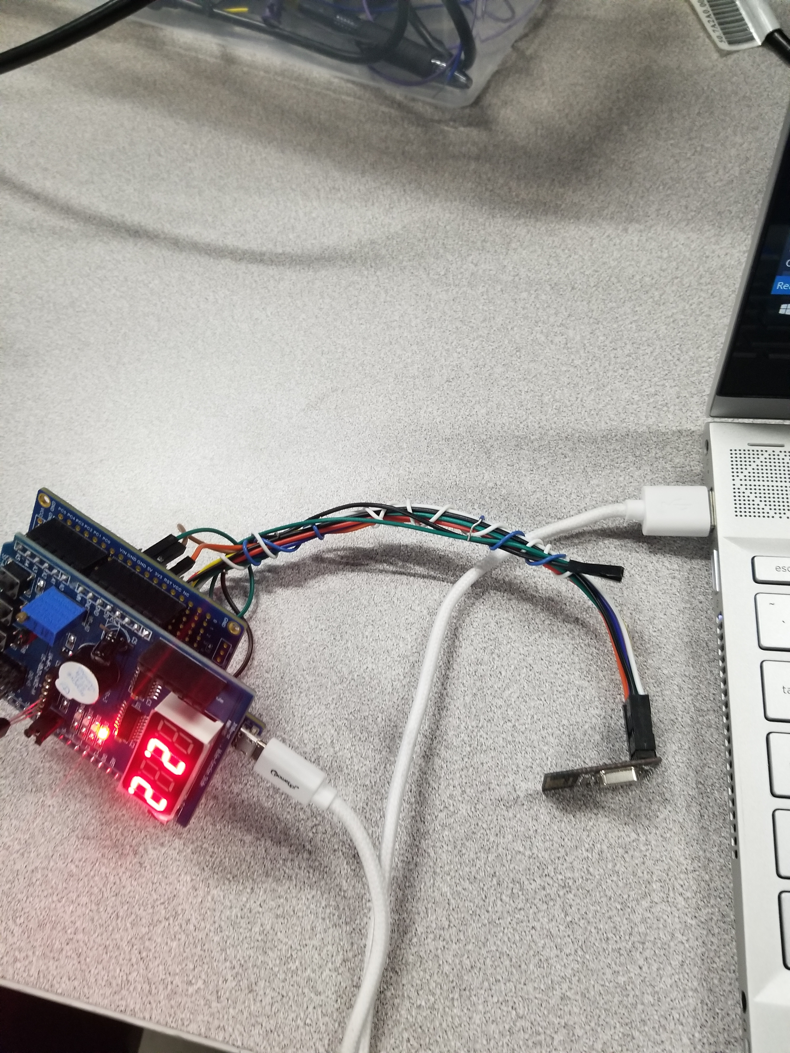

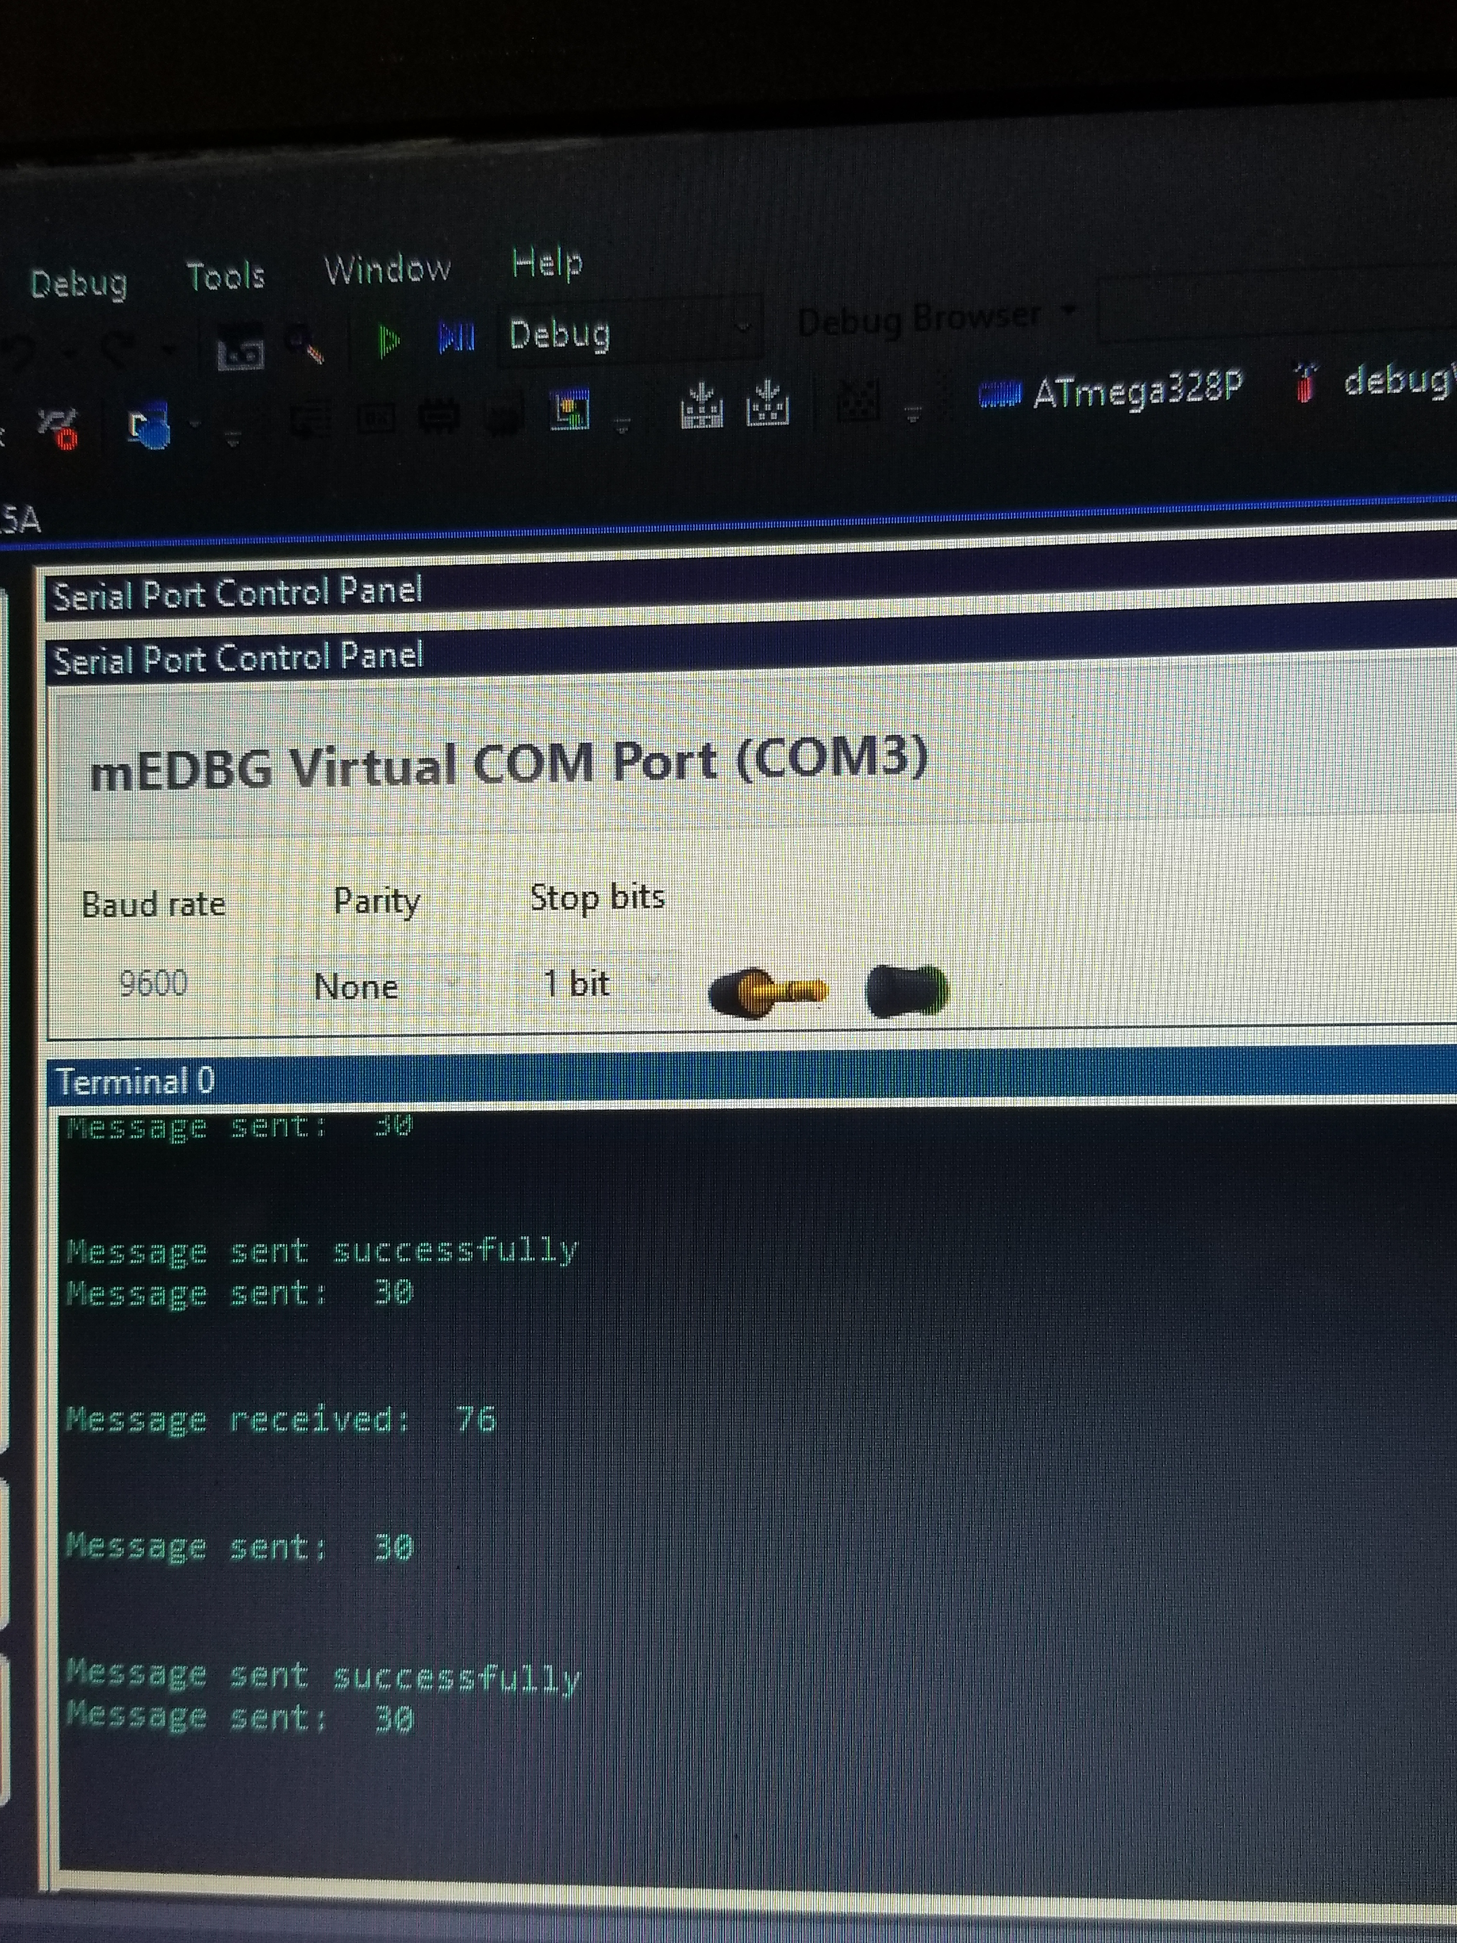

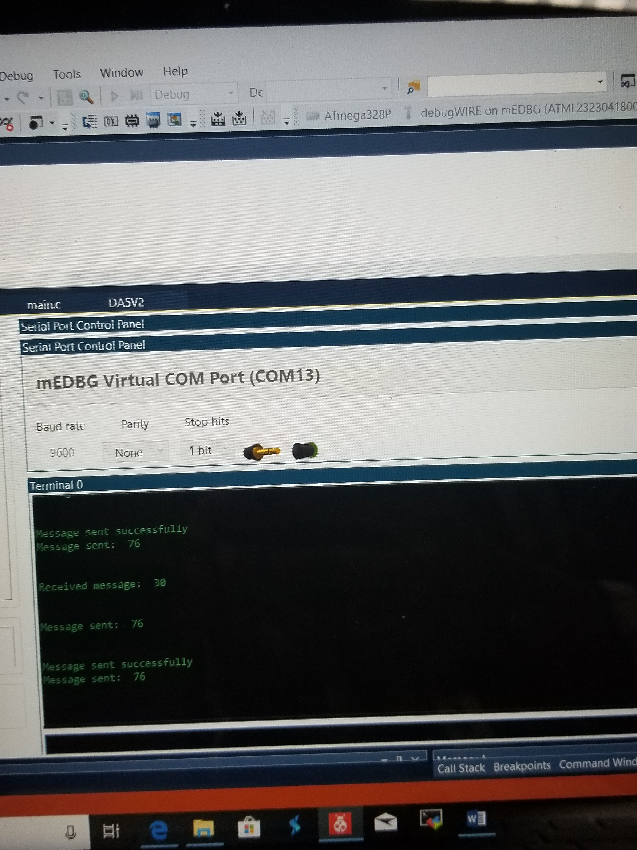

1. **VIDEO LINKS OF EACH DEMO**

[**https://youtu.be/gG4vMLw5njw**](https://youtu.be/gG4vMLw5njw)

1. **GITHUB LINK OF THIS DA**

<https://github.com/sawar1/UNLV301>

**Student Academic Misconduct Policy**

<http://studentconduct.unlv.edu/misconduct/policy.html>

“This assignment submission is my own, original work”.

RIMON SAWA